Object-Oriented Language and Theory

Lecturer: Nguyen Thanh Hung, [hungnt@soict.hust.edu.vn](mailto:trangntt@soict.hust.edu.vn)

Teaching Assistant: Nguyen Trung Thanh (thanh.nt176874@sis.hust.edu.vn)

**Lab 07: Abstract Class and Interface**

**\* Objectives:**

In this lab, you will practice with:

* Creating abstract class, abstract methods
* Creating interface and implement it
* Using Threads

You need to use the project that you did with the previous labs including both AimsProject and other projects. Please follow the Release Flow to commit and push to the bitbucket.

**1. Import the AimsProject**

**- Open Eclipse**

- Open File -> Import. Type zip to find Archive File if you have exported as a zip file before. You may choose Existing Projects into Workspace if you want to open an existing project in your computer. Ignore this step if the AimsProject is already opened in the workspace.

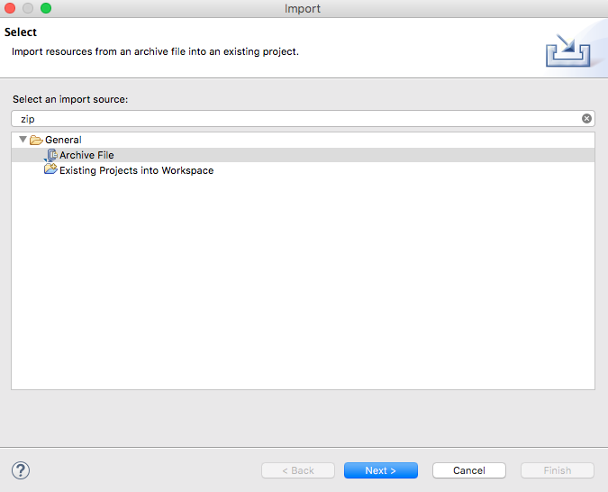

- Click Next and Browse to a zip file or a project to open

**2. Extending the AIMS project to allow the ordering of CDs (Compact Discs)**

As with **DigitalVideoDisc** and **Book**, the **CompactDisc** class will extend **Media**, inheriting the **title**, **category** and **cost** fields and the associated methods.

You can apply Release Flow here by creating a **topic** branch for making the **Media** class abstract.

**2.1. Make the Media as an abstract class**

- Open **Media** class

- Modify the **Media** class and make it **abstract**

- Keep three fields of **Media**: **title**, **category**, **cost** and their associated methods, but remove the setters.

**2.2. Create the Disc class extending the Media class**

- The **Disc** class has two fields: **length** and **director**

- Create **getter** methods for these fields

- Create constructor(s) for this class. Use super() if possible.

- Make the **DigitalVideoDisc** extending the **Disc** class. Make changes if need be.

- Create the **CompactDisc** extending the **Disc** class. Save your changes.

**2.3. Create the Track class which models a track on a compact disc and will store information incuding the title and length of the track**

- Add two fields: **String** **title** and **int** **length**

- Make these fields **private** and create their **getter** methods as **public**

- Create constructor(s) for this class.

- Save your changes

**2.4. Open the CompactDisc class**

- Add 2 fields to this class:

* a **String** as **artist**
* an **ArrayList** of **Track** as **tracks**

- Make all these fields as **private.** Create public **getter** method for only **artist**.

- Create constructor(s) for this class. Use super() if possible.

- Create methods **addTrack**() and **removeTrack**()

* The **addTrack**() method should check if the input track is already in the list of tracks and inform users
* The **removeTrack**() method should check if the input track existed in the list of tracks and inform users

- Create the **getLength**() method

* Because each track in the CD has a length, the length of the CD should be the sum of lengths of all its tracks.

- Save your changes

**3. Create the Playable interface**

The **Playable** interface is created to allow classes to indicate that they implement a **play**() method. You can apply Release Flow here by creating a **topic** branch for implementing **Playable** interface.

- Create **Playable** interface, and add to it the method prototype: **public void play();**

- Save your changes

- Implement the **Playable** with **CompactDisc**, **DigitalVideoDisc** and **Track**

* For each of these classes **CompactDisc** and **DigitalVideoDisc**, edit the class description to include the keywords **implements** **Playable**, after the keyword **extends** **Disc**
* For the **Track** class, insert the keywords **implements** **Playable** after the keywords **public** **class** **Track**

- Implement **play**() for **DigitalVideoDisc** and **Track**

* Add the method **play**() to these two classes
* In the **DigitalVideoDisc**, simply print to screen:

public void play() {

System.out.println("Playing DVD: " + this.getTitle());

System.out.println("DVD length: " + this.getLength());

}

* Similar additions with the **Track** class

- Implement **play**() for **CompactDisc**

* Since the **CompactDisc** class contains a **ArrayList** of **Tracks**, each of which can be played on its own. The **play**() method should output some information about the **CompactDisc** to console
* Loop through each track of the arraylist and call **Track's** play() method

**4. Update the Aims class**

- You will update the **Aims** class to test your changes.

* Create more choices for your application
* Update the menu of choices:
  + For the addition of new item to the order, the program should ask for the type: **Book**, **CompactDisc** or **DigitalVideoDisc**
  + For the **CompactDisc**, the program should allow to add information of **Tracks**
  + When adding a cd/dvd to the order, the user may ask for play them

- You will update the class diagram for the above classes and interfaces.

**5. Practice with Threads changes**

A class called **MemoryDaemon** runs as a daemon thread, tracking the memory usage in the system.

- The **MemoryDaemon** class implements the **java**.**lang**.**Runnable** interface

- Implement the **run**() method

- Add the field **long** **memoryUsed** to the **MemoryDaemon** class

- Initialize this field to 0. It keeps track of the memory usage in the system.

- Add code to the **run**() method to check memory usage as the program runs

Create a loop which will log the amount of memory used as the **Aims**.**main**() method executes. You will make use of the **java**.**lang**.**Runtime** class, which has a static method **getRuntime**().

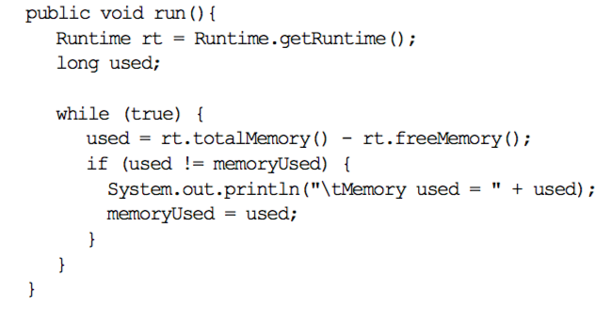

- Save your changes

**5.2. Updating the Aims class**

The **Aims** class will create a new **MemoryDaemon** object and run it as a daemon thread

- Open the **main**() method of **Aims** class

- Add code to create a new **MemoryDaemon** object

- Use this object in the constructor of the **Thread** class to create a new **Thread** object

- Using the **setDaemon**() method to indicate that this thread is a daemon thread, add code to start the thread.

- Save your changes

Run the program and see the changes.**..**